Control Phase 2

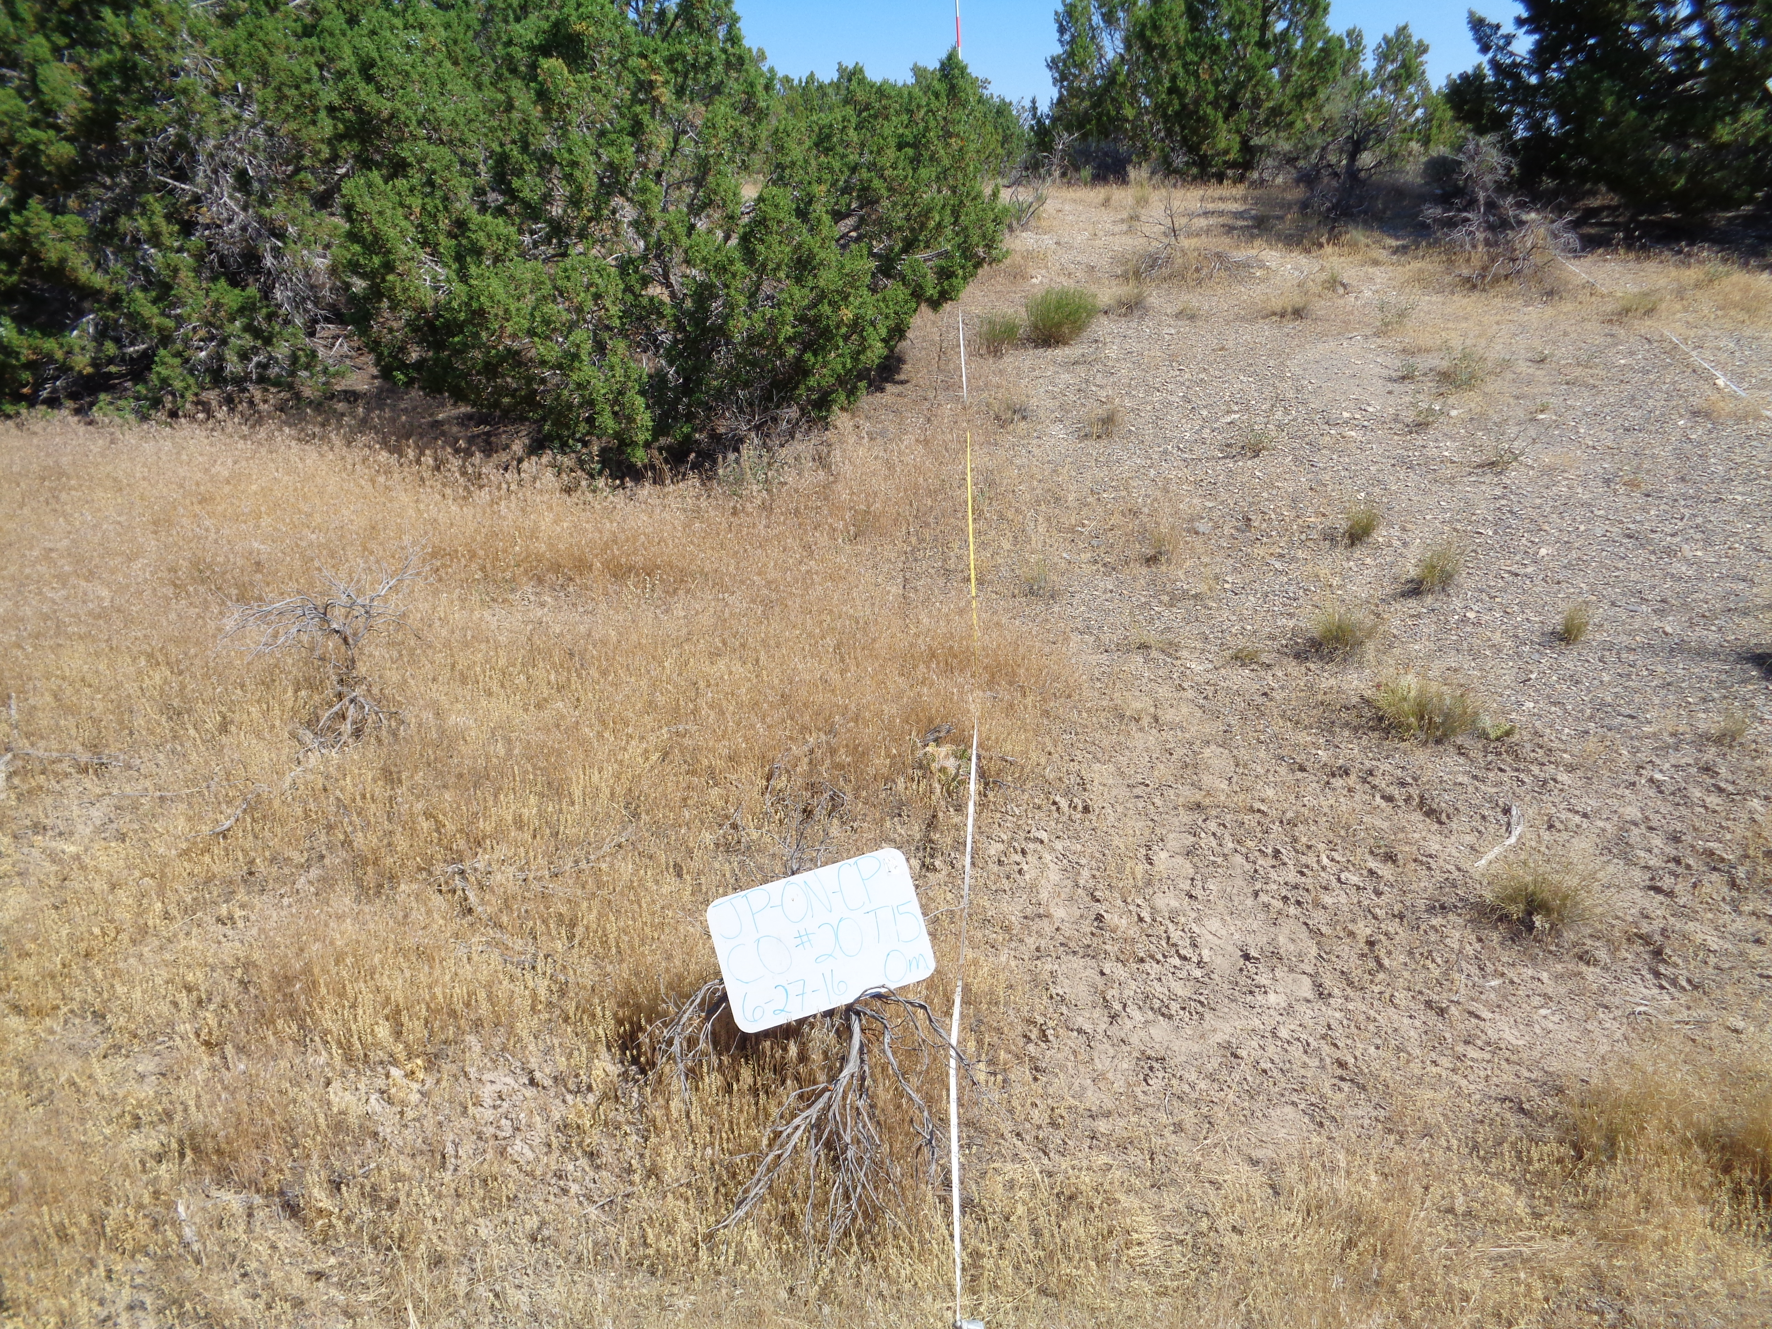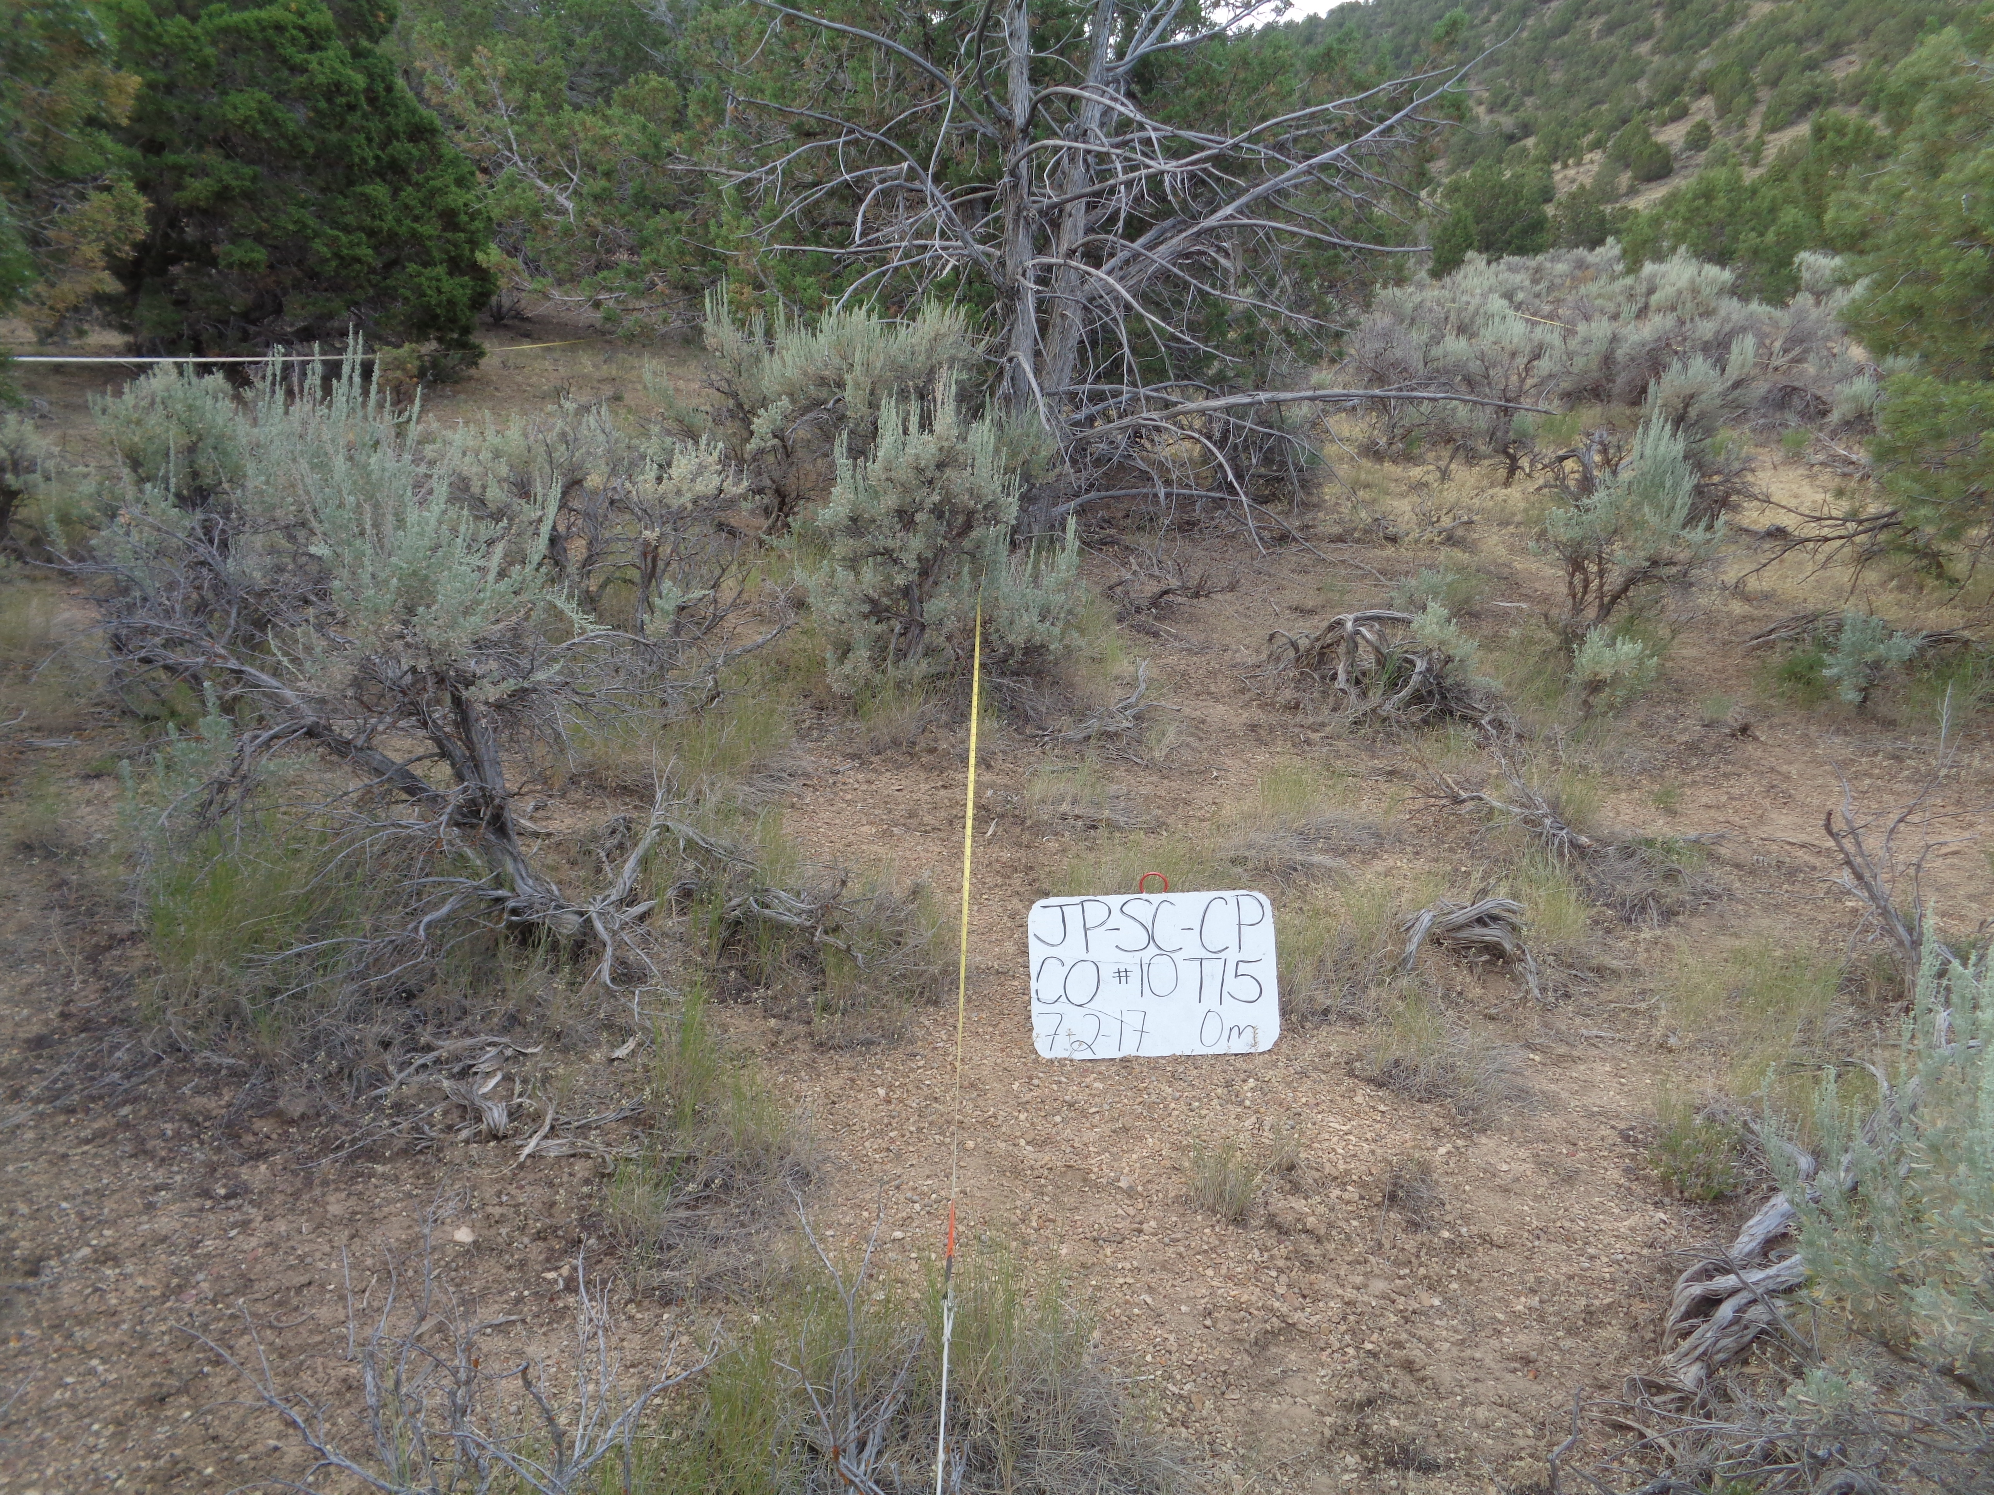

|  |  |  |  |  |  |
| --- | --- | --- | --- | --- | --- |
| Control Phase 2 | | | | | |
| Variable | Category | Component | Min | Mean | Max |
| **Total Cover (%)** | Trees | JUOS |  |  |  |
| PIED |  |  |  |
| Shrubs | ARTRV |  |  |  |
| ARTRW8 |  |  |  |
| CHVI8 |  |  |  |
| PUTR2 |  |  |  |
| Herbaceous | Perennial Grass |  |  |  |
| Annual Grass |  |  |  |
| Forb |  |  |  |
| Litter & Duff | Interspace Litter |  |  |  |
| Bare Ground | Bare Ground |  |  |  |
| **Density (#/acre)** | Trees | JUOS |  |  |  |
| PIED |  |  |  |
| Shrubs | ARTRV |  |  |  |
| ARTRW8 |  |  |  |
| CHVI8 |  |  |  |
| PUTR2 |  |  |  |
| **Height (in)** | Shrubs | ARTRV |  |  |  |
| ARTW8 |  |  |  |
| CHVI8 |  |  |  |
| PUTR2 |  |  |  |
| Herbaceous | Grass |  |  |  |
| Forb |  |  |  |
| **Fuel Loading (tons/acre)** | Downed Woody Debris | 10-hr |  |  |  |
| 100-hr |  |  |  |
| 1000-hr sound |  |  |  |
| 1000-hr rotten |  |  |  |
| Litter & Duff | Interspace Litter |  |  |  |
| Tree Litter + Duff |  |  |  |
| Herbaceous | Live |  |  |  |
| Dead |  |  |  |
| Total |  |  |  |
| Shrub | ARTRV |  |  |  |
| ARTRW8 |  |  |  |
| CHVI8 |  |  |  |
| PUTR2 |  |  |  |
| **Bulk Density (lbs/ft3)** | Shrub | ARTRV |  |  |  |
| ARTRW8 |  |  |  |
| CHVI8 |  |  |  |
| PUTR2 |  |  |  |
| Herbaceous | Live + Dead |  |  |  |
| Litter & Duff | Tree Litter + Duff |  |  |  |
| **Depth (in)** | Litter & Duff | Tree Litter + Duff |  |  |  |